Revolution in the German Capital Market: Securities Become Digital
Philipp Sandner
Follow
Aug 11 · 6 min read
The legislator has drafted a proposal for digital securities that could trigger a revolution in the German capital market. Four aspects point in this direction: First, securities are being detached from the paper-based certificate in a systematic way, thus dematerialized, which creates the basis for the digital capital market of the future. Second, in the future, there will be the possibility that in addition to the central securities depository Clearstream — which belongs to Deutsche Börse — other registers perform the same function. Competition is therefore guaranteed. Third, the legislator also enables issuers themselves — possibly even industrial corporations — to keep the register for their own securities. Fourth, the legislator is creating the necessary conditions under German law for securities to be issued on decentralized blockchain systems such as possibly Ethereum — the second largest crypto currency after Bitcoin. — Philipp Sandner, Johannes Blassl
The German version of this article can be found here.

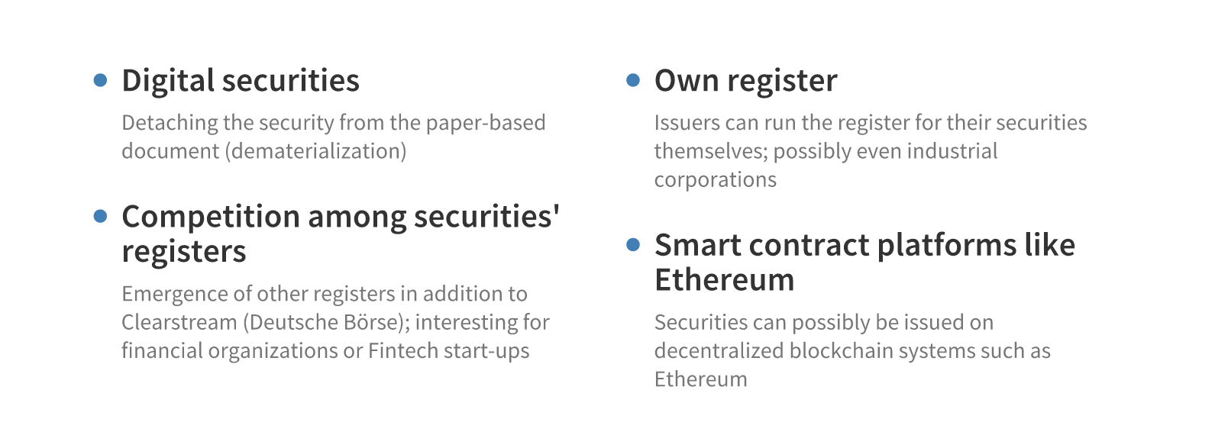
Figure 1: Four essential aspects of the draft on electronic securities
Currently, securities in Germany require the existence of a paper certificate, i.e., a printed and hand-signed text file. These are stored in a safe at a so-called central securities depository (CSD). In 2020, the storage of paper-based documents in a safe seems somewhat anachronistic, a system that is over a hundred years old in Germany.
Of course, an investor nowadays can buy and sell securities in seconds using an online brokerage service. This apparently happens “digitally” and works seamlessly, but in the background, there is still a physical certificate in paper form in a safe. Together with the involvement of more than 40 persons in a securities transaction, this leads to inefficiencies and, thus to costs. The need for securities to be paper-based also hampers digital innovations.
The German legislator now intends to break with this existing system. For a long time, the draft bill for the introduction of electronic securities was awaited. Now the draft bill of the Federal Ministry of Finance and the Federal Ministry of Justice and Consumer Protection is circulating and indicates a tidal turn.
In several aspects, the draft bill can be considered revolutionary. The mandatory requirement of paper-based documents no longer applies. Even the sole CSD, in Germany Clearstream, a subsidiary of Deutsche Börse, could face competition from companies performing the same function in the future. Securities would then not only be stored and managed by Clearstream but also by stock exchanges, banks, or even the issuers themselves.
In particular, the decision to open up security trading for the electronic issuance of securities is based on blockchain technology, which is a very efficient solution for the trading of digital securities.
Another reason for the proposed legislation is to maintain the attractiveness of the German financial center, as securities transactions can already be carried out internationally under progressive — i.e., transaction-friendly — legislation. Although it is only a draft bill, the law to be implemented in the future will significantly change the capital market in Germany and the players operating there. Digitization will now affect the entire capital market. It is not presumptuous to say that in five years, no one will put pieces of paper in the safe if sufficient data security can be provided by blockchain technology. The proposed law creates the foundation, therefore.
The primary purpose of the draft bill is to remove bearer bonds from the paper-based document requirement and thus make digital securities possible. However, the option of traditional issuing of securities using certificates will not be abolished, but the possibility of issuing electronic securities will open up a new alternative. From a technical point of view, this can be done by using blockchain technology. However, the legislator is deliberately acting in a technology-neutral way and would also allow other technologies.
In the future, issuers of securities will have an option. They can continue to rely on the paper form and the certificate printed on it or issue securities “dematerialized” in digital form. The latter could be achieved through the creation of an electronic securities register, presumably provided by Clearstream, where it probably already exists to a large extent. It can be expected that issuers will tend to choose the new, digital alternative more often from year to year due to the advantages in terms of costs and faster tradability. Also, the legislator is opening up the possibility of converting “analog” securities into digital ones. In this way, the government is creating the foundation for the migration of old securities holdings to the new, digital world.
Furthermore, it is fascinating that, in addition to the CSD Clearstream, the legislator intends to allow other companies that could provide the same service. In the draft legislation, therefore, such services are introduced as crypto security registry management which can be implemented in different ways. Other existing banks and financial service providers, for instance, could offer the issuing of digital securities in the same way as the CSD. For smaller companies such as FinTech startups, this is also conceivable. Nevertheless, the legislator goes even further: The issuers themselves can also keep the register for their securities. In principle, this would even allow an industrial corporation to manage the register for its securities.
In any case, by introducing these new variants, the legislator is creating an appropriate balance between the need to preserve existing structures and the promotion of new, emerging decentralized structures, which can be equally attractive for large financial institutions and startups.
The legislator will, therefore, significantly change the existing structure of intermediaries, for example, by allowing the direct entry of the investor in the register.
Yet another exciting aspect: The legislator is suggesting that the issuing of digital securities does not necessarily have to take place on a privately operated (permissioned) blockchain system. Instead, it would also be feasible to do so on public (permissionless) blockchains. In this way, the legislator would create the possibility that securities under German law could possibly even be issued based on Ethereum — currently the second most important crypto currency after Bitcoin.
The present draft is explicitly limited to bonds, i.e., instruments for debt financing. However, the draft bill is intentionally formulated generically, so that the regulations could later — once they have proven their usefulness — be applied to stocks or investment funds. According to the draft statement, an application to stocks and fund shares is strongly intended.
It was worth the wait. The methodology and depth of detail in the draft bill and its rationale are convincing. Thus, the legislator is driving the digitization of the capital market in a visionary way. A harmonized regulation for the trading of securities on the European level, which has been planned for some time, is briefly discussed in the draft bill, but will not be awaited. Furthermore, the draft bill contains a kind of IT system specification that clarifies the requirements for the IT implementation of digital securities processes.
The draft bill also shows the profound expertise that is now existing in the ministries involved. Despite all the enthusiasm, the only thing that helps now is to wait until the draft bill has gone through the legislative process, hopefully as undamaged as possible. However, this will be the future. The “old” system of securities trading will possibly be replaced entirely in a few years.

Authors
Prof. Dr. Philipp Sandner is head of the Frankfurt School Blockchain Center (FSBC) at the Frankfurt School of Finance & Management. The expertise of Prof. Sandner includes blockchain technology in general, crypto assets, distributed ledger technology (DLT), Euro-on-Ledger, security tokens (STOs), digital transformation and entrepreneurship.
Dr. Johannes Blassl works as a lawyer in Frankfurt in the field of banking and capital markets law. He advises companies and banks on the use of blockchain technology in the financial sector. In addition to his work as a lawyer, Dr. Johannes Blassl is a lecturer at the EBS Law School in Wiesbaden and the Universities of Applied Sciences in Fulda and Mainz.

